PERSONAL INFORMATION | Mariya Jose
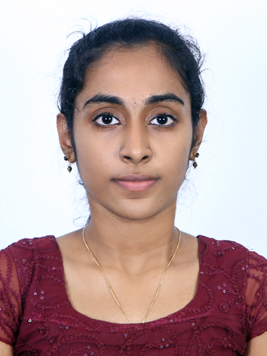 |   Poozhikolayil House, Colonypadi, Erumathala PO, Ernakulam, 683112, Kerala, India

+91 8078 862541  +91 94950 75401

mariajosepoozhikolel@gmail.com
 | Sex Female | Date of birth 20/01/2002 | Nationality Indian

STUDy APPLIED FOR | MSc Biotechnology

EDUCATION AND TRAINING

November 2020- May 2024  July 2018- May 2020  June 2017- May 2018 | B. Tech Biotechnology
 | MET’s School of Engineering Mala, Thrissur, Kerala, India
8.02 CGPA

Plus Two Bio- Mathematics
St. Mary’s HSS Morakala, Kerala, India
91%

Tenth (High School)
Nirmala HSS Aluva, Ernakulam, Kerala, India
98%

PERSONAL SKILLS

Mother tongue(s) | Malayalam
Other language(s) | UNDERSTANDING |  | SPEAKING |  | WRITING
Other language(s) | Listening | Reading | Spoken interaction | Spoken production
English | B1/2 | B1/2 | B1/2 | B1/2 | B1/2
 | IELTS Academic
Hindi | B1/2 | B1/2 | B1/2 | B1/2 | B1/2
Levels: A1/2: Basic user - B1/2: Independent user - C1/2 Proficient user
Common European Framework of Reference for Languages

Communication skills | Excellent Interpersonal Communication Skills

Computer skills | Expertise in Microsoft Office tools  Excellent in MSc Excel, PowerPoint, Word, Outlook

Other skills | Dancer, Music

ADDITIONAL INFORMATION

Certificates  References | American Society For Microbiology & MES College Marampally  Pharmaceutical Quality Control Organized By Unibiosys Biotech Research Lab  ICMR -2023 International Conference on Antimicrobial Resistance  Internship on Genetic Engineering from IIT Bhubaneswar  Internship on tissue culture techniques from Karottukizhakkel Biotech Pala,Kottayam  Mr Deepak Varghese - MET'S School of Engineering -  HOD, Department of Biotechnology  +91 9746246934

