Resume

# Personal details

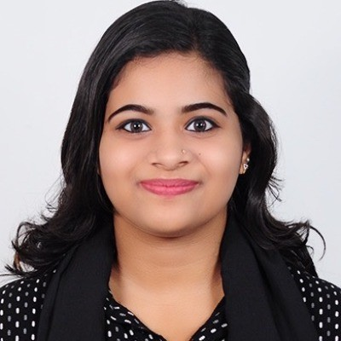**Name** Rimal Shamse

**Email address** [rimalshamse@gmail.com](mailto:rimalshamse@gmail.com)

**Phone number** +91 9072183787

**Address** Thekkumkattil (H), Market, P O, Muvattupuzha, 686673 ERNAKULAM

**Date of birth** June 25, 2002

**Place of birth** Dubai, UAE

**Driver's license** DL No. KL 20210003303

**Gender** Female

**Nationality** INDIA

**Civil status** Unmarried

# Education

**Oct 2020 - Mar 2023 BACHELOR OF COMMERCE IN OFFICE MANAGEMENT AND**

**SECRETARIAL PRACTICE**

**Nirmala College, Muvattupuzha**

 Achieved a **B** grade with an overall percentage of **58%**.

 Gained knowledge in office administration, communication skills, and organizational management.

 Completed projects that enhanced practical skills in a professional enivronment.

**Jun 2018 - Jul 2020 HIGHER SECONDARY CERTIFICATE**

**T.T.H.S.S, Muvattupuzha**

 Completed a comprehensive curriculum focused on computer application, commerce principles, and information technology.

 Achieved a percentage of **68%** demonstrating a solid understanding of core concepts and skills.

 Engaged in projects that enhanced teamwork and problem- solving abilities.

**May 2017 - May 2018 SECONDARY SCHOOL CERTIFICATE**

**Ilahia Public School, Muvattupuzha**

 Achieved **64%** in final examinations.

 Developed foundational skills in subject such as Mathematics, English, and Science.

 Participated in extracurricular activities that enhanced teamwork and leadership abilities.

# Skills

**Communication Skills** Good

**Data Entry** Good

**Time Management** Very good

**Research Skills** Very good

# Languages

**English** Good

**German** Moderate

**Malayalam** Very good

# Hobbies

Reading

Dancing

 Photography

# Qualities

Problem-solving

Self-motivation

Active Listening