**EMBASSY INTERVIEW FEEDBACK FORM – STUDENT STATEMENT**

**Name of the Student: _Biyon Vincent____________________**

**Passport Number:_W2632973________________________**

**University/Institution Name:__University of Maribor_______________________**

**Section 1: Interview Details**

**Date of interview: _30.10.2024____________________________________**

**Time of interview: _9:30AM___________________________________**

**Location of interview: _Delhi_________________________________**

**Scheduled time: _10:00AM______________________________________**

**Reporting time: _8:45AM________________________________________**

**Section 2: Waiting Time and Process**

1. **How long did you wait before submitting your biometrics and interview?**

**____About_3_months_______________________________________________________________________________________________________________________________________________________________________________**

1. **Were there any issues or concerns during the questionnaire or biometric process? If yes, please describe:**

**No_there_was_no_issues_______________________________________________________________________________________**

**Section 3: Interview Questions**

**1.Please list the questions and answers given during the interview:**

**In my case there was interview for me there was only biometrics**

**2. Were there any questions that you felt were unnecessary or confusing? If yes, please specify:**

**NO**

**___________________________________________________________________________________________**

**Section 5: Interview Experience**

**How would you rate the behavior of the interviewer? (Scale: 1-5, where 1 is very discourteous and 5 is very respectful) _______________________**

**Did you feel comfortable and at ease during the interview? Yes No**

**Were there any questions that made you feel uncomfortable or defensive? If yes, please describe:**

**NO_______________________________________________________**

**Did the interviewer provide clear explanations and support during the interview? Yes No**

**Section 6: Additional Comments**

**Is there anything else you would like to share about your interview experience?**

**NO**

**Section 7: Rating**

**On a scale of 1-5, how would you rate your overall experience at the Slovenian Embassy in India? (1 is very poor and 5 is excellent) _Excellent______________________**

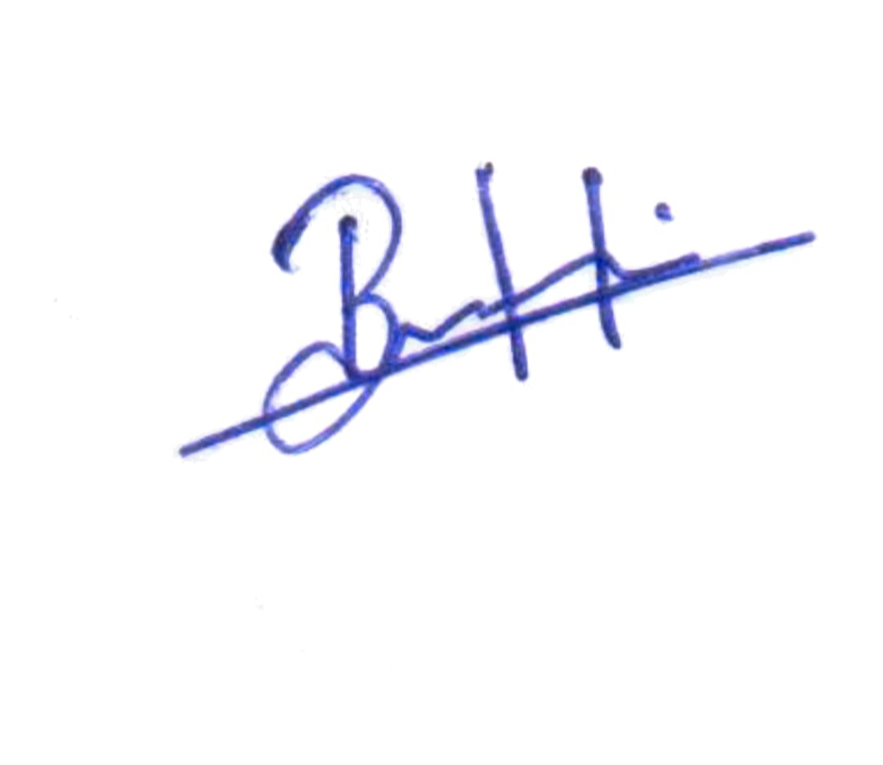**Place:Kannur Kerala**

**Signature:_____** **_________**

**Date: 5.11.2024**

**Thank you for taking the time to provide us with your feedback**