 **DHRUV GARG**

**CURRICULUM VITAE**

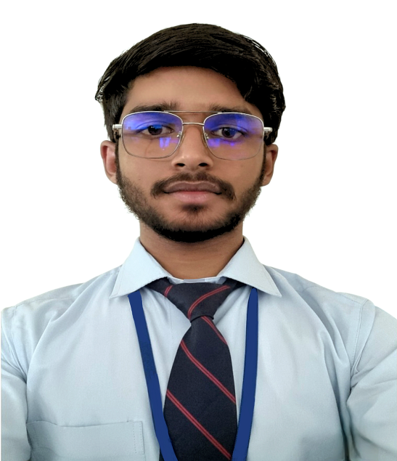

**DHRUV GARG**

1022, MeethaKuwaMohalla , Near KhedaMandir , Buria

Pin :- 135101, Haryana, India

+91 99916-46667

Email ID:-[dhruvgarg4562@gmail.com](mailto:dhruvgarg4562@gmail.com)m

Whatsap , IMO :- 99916-46667

Sex- Male| Date of Birth – 30/01/2003 |Nationality – Indian

EDUCATION AND TRAINING

Examination Board/University Grade Session

10th CBSE 2018

12TH HBSE 72% 2020

BCA Kurukshetra University 74% 2023

LANGUAGE COURSE

IELTS/PTE TEST DATE SCORE SESSION

IELTS 04/11/2023 7.0 2023

PERSONAL DETAIL

Father Name Date of Birth Sex Marital Status

Deepak kumar 30/01/2003 Male Single

Passport Details

Passport No. Date of Issue Date of Expiry Place of Issue

Y7799189 06/09/2023 05/09/2033 CHANDIGARH

PERSONAL SKILLS

MOTHER TONGUE HINDI

English ,Hindi

Other language(S)

Commnication

* Excellent written and verbal communication skills.
* Empathic listener and persuasive speaker.
* Writing creative or factual.
* Speaking in public, to groups, or via electronic media.
* Excellent presentation and negotiation skills.