Visa Disclaimer
1) It is the responsibility of the student to submit the ORIGINALS of the non-academic documents at the consul / VFS and any negative decisions on visa upon not submitting the ORIGINAL documents or due to the forgery of the documents submitted shall not be the responsibility of Europe Study Centre.

2) It is OBLIGATORY that the complete checklist of documents including the COVER LETTER must be submitted to Head Office for the purpose of verification, and if the student carries any extra document without approval from the HO, is at the sole discretion of the student and HO cannot hold the responsibility for this document in case of visa refusal.

3) It is MANDATORY that the ordering and the verification approval of the visa checklist documents is obtained from the respective Processing Coordinator before the student is shared with the Visa Mediation Papers and appointment confirmation.

4) The student shall not be entitled for the tuition fee refund in case of visa refusal for the following reasons:
- forgery of the documents submitted for visa
- the student showing unwillingness to submit the additional documents requested by the embassy
- student showing unwillingness to submit the ORIGINALS of the non-academic documents and other prescribed documents as per the visa checklist
- Student submitting any extra document without the verification or approval from head office without any request from the consul/ VFS.
- Incomplete documents as per the checklist
- For Lithuania: All students have to undergo check and verify service.
5) The student must cooperate and must be willing to submit any additional documents as requested by the embassy for the smooth processing of their visa decisions.

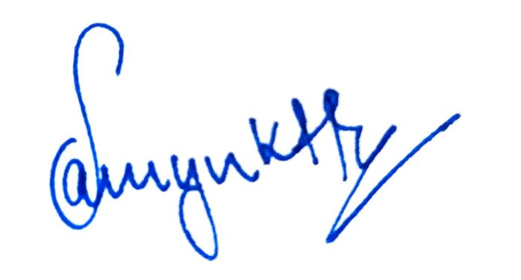
Signature
Date: 19.06.2024
Place: Bengaluru, Karnataka

