

|  |
| --- |
| **AKSHAY CHANDRAN**  **Nationality:** Indian +91 7902969395  **Email address**: akshay318318@gmail.com  AKSHY NIVAS, MANAKKALA, VAZHICHAL P.O , 695125 TRIVANDRUM,KERALA, INDIA  **Address:** |

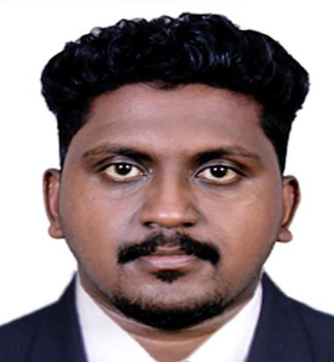

# WORK EXPERIENCE

01/12/2022 - 04/05/2024 - Trivandrum, India

Administrative Assistant - FARIN TRENDS TEXTILES

# EDUCATION AND TRAINING

# 2022

**Master Diploma in Civil CAD**

**CAD DESK**

**Field of study**  Masters in Diploma  **final Grade -** Good

2018 - 2020

**Diploma in surveyor**

R GANESH MEMORIEL VICTORY PRIVATE ITI -THRISSUR

**Filed of study -** Diploma   **Final Grade -** 80%

2016 - 2018 India

**Higher Secondary School-** **JANARDHANAPURAM HIGHER SECONDARY SCHOOL**

**Field of study -**  Science  **final Grade - 68%**

2015 - 2016 India

**Senior Secondary – JANARDHANAPURAM HIGHER SECONDARY SCHOOL**

**Field of study -** Senior Secondary  **Final Grade -** 78%

# SOFTWARE SKILLS

3DS Max , AutoCAD, Revit Architecture, MS Office

# LANGUAGE SKILLS

Mother tongue(s): **MALAYALAM**

Other language(s): **English,** **Malayalam ,Hindi**

## UNDERSTANDING SPEAKING WRITING

Listening Reading Spoken

Production

Spoken interaction

**ENGLISH** C2 C1 C2 C2 C1

*Levels: A1 and A2: Basic user; B1 and B2: Independent user; C1 and C2: Proﬁcient user*