REQUEST FORM

First Name : AKSHAY GIRISH
Last Name : GIRISH
Address : KARIPPALLIMALAYIL
VADAKARA, KOTTAYAM
PIN:686605,KERALA,INDIA

Program of Study : Economics and management of public administration
Year of Study : 2024-2025

I hereby student request for | Refund of tuition fee
Please state full reasons for your request | Due to visa rejection

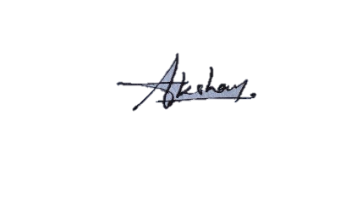
Student signature

Vice Dean for Education: I approve – I do not approve

Vice Dean for International Relations and Development: I approve – I do not approve
Dean′s statement: I agree – I do not agree

